GFMI dq Admittance Extraction Using Raised-Cosine Pulse
Objective of the test
The aim of this test was to identify the 2×2 dq admittance matrix of the switching GFMI using a raised-cosine pulse method.
The admittance matrix is:
Ydq = [Ydd Ydq]
[Yqd Yqq]
The method uses two PSCAD pulse simulations. d-axis pulse, q-axis pulse.
The code converts the measured PCC voltage/current from abc to dq, applies FFT to the pulse response, calculates the admittance matrix as Ydq = Idq / Vdq, rejects unreliable frequency bins, compares the pulse result with sinusoidal references, and checks small-signal linearity using a smaller pulse amplitude.
This section evaluates whether a single raised-cosine pulse injection (one d-axis pulse run and one q-axis pulse run ) can replace multiple sinusoidal scans across a low-frequency range, while maintaining acceptable accuracy for impedance-based stability analysis.
The raised-cosine pulse shape was selected over rectangular and Gaussian shapes based on preliminary analytical R-L circuit tests, where the raised-cosine produced the cleanest spectral characteristics with minimal sidelobes, reducing leakage into adjacent frequency bins.
Perturbation:
- d-axis pulse: raised-cosine added to voltage magnitude source, amplitude A = 0.005 pu, width T_w = 0.5 s, start time t = 2.0 s
- q-axis pulse: raised-cosine added to phase angle source, amplitude A = 0.5 degrees, same timing
Linearity check: repeated at A = 0.0025 pu / 0.25 degrees (half amplitude)
Reference: dedicated sinusoidal PSCAD scans at 0.5, 1, 2, 3 Hz using 12.5 µs solver step
Solver step: 50 µs logging, 12 second simulation duration

Time domain pulse response
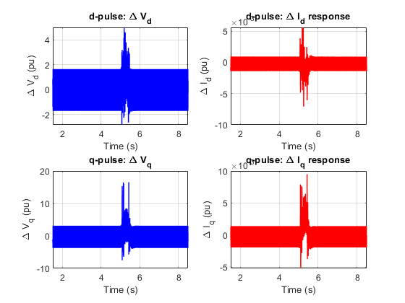
dt = 50.00 us
fs = 20000 Hz
d-offset = -0.847345 rad
q-offset = -0.847345 rad
diff = 0.000000 rad
Window = 2.0–12.0 s
Pre-pulse amp = 1.478e-02
Late = 1.403e-03
The d-axis and q-axis pulse responses were both successfully applied and produced visible current responses. The dq angle offset was identical for both pulse runs, with zero difference between the d-pulse and q-pulse reference angles. The response also decayed sufficiently before the end of the selected FFT window.
The dq angle alignment is important because the d-pulse and q-pulse results are later combined into one 2×2 dq admittance matrix. If the dq reference frames were different, the two columns of the admittance matrix would not be consistent.
The decay check confirms that the response has mostly returned close to the normal steady-state ripple level by the end of the window. This is important because FFT-based extraction should not be performed on a response that is still strongly growing or not settled. The purpose of this plot is not to show a clean sinusoid, but to verify that the pulse was applied and the response was recorded.

DQ admittance magnitude
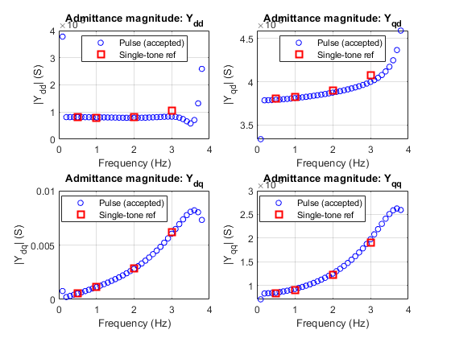
This plot shows the pulse-derived accepted admittance points and the single-tone reference markers for Ydd, Yqd, Ydq, Yqq.
The pulse-derived admittance curves are mostly smooth from low frequency up to around 3.8 Hz. The pulse result agrees well with the single-tone references at 1 Hz and 2 Hz for all four matrix elements.
Reasoning
The smooth trend indicates that the FFT-based pulse extraction is producing consistent frequency-response data, not random scattered noise. The strong agreement at 0.5 Hz, 1 Hz, and 2 Hz suggests that the pulse method is reliable in this low-frequency range.
The mismatch in Ydd near 3 Hz suggests that this element is more sensitive to pulse amplitude, spectral leakage, or numerical extraction error. This is also confirmed later by the reference-error and linearity plots.
Conclusion
The dq admittance magnitude plot supports the pulse method for low-frequency GFMI admittance estimation. However, Ydd at 3 Hz should not be accepted as a final accurate result.

DQ admittance phase
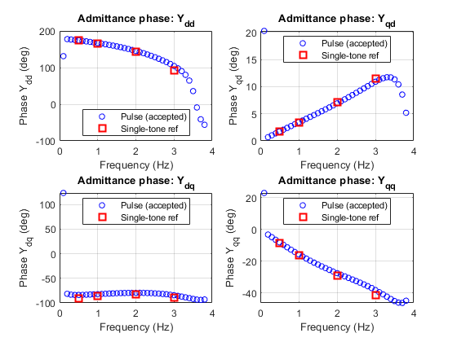
This plot shows the phase of the four admittance elements and compares the pulse result with the single-tone reference markers.
The phase curves are mostly smooth over the accepted low-frequency range. The single-tone reference markers generally follow the same trend as the pulse-derived phase results.
However, phase agreement alone is not enough to validate the result. The complex error calculation is more important because it includes both magnitude and phase mismatch.
Conclusion
The phase plot supports the consistency of the pulse extraction over the accepted low-frequency range. The larger deviation around Ydd at 3 Hz agrees with the error table, so that point should be treated as unreliable.

MIMO condition number
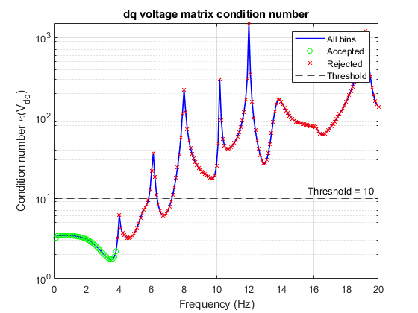
Accepted: 34/200 = 17.0%
The accepted bins are mainly from = 0.1 Hz to 3.8 Hz
The condition-number threshold used was - cond_threshold = 10
The low-frequency accepted region has a low condition number, approximately around 2–4. Above this frequency range, the condition number rises sharply and many bins are rejected.
Reasoning
The admittance is calculated using:
Ydq = Idq / Vdq
This requires inversion of the 2×2 dq voltage matrix. If the voltage matrix has a high condition number, the inversion becomes sensitive to noise and small numerical errors. Therefore, high-condition-number bins are not reliable.
The condition-number plot explains why the accepted bins are mainly in the low-frequency range. The voltage matrix is well-conditioned at low frequencies but becomes unreliable at higher frequencies.
Conclusion
The accepted low-frequency bins are numerically reliable for matrix inversion. Higher-frequency bins should not be used because the dq voltage matrix becomes poorly conditioned.

Pulse vs single-tone reference error
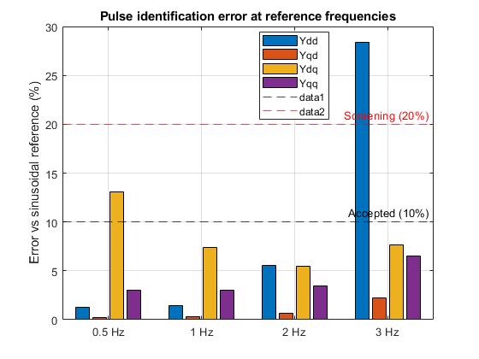
The pulse method gives strong agreement with the single-tone reference at 1 Hz and 2 Hz. At these two frequencies, all four dq admittance elements are below the 10% acceptance threshold.
At 0.5 Hz, three elements are accepted, but Ydq is classified as screening-only because the error is between 10% and 20%.
At 3 Hz, three elements are accepted, but Ydd is rejected because the error is above 20%.
Reasoning
The 1 Hz and 2 Hz points are reliable because they pass the reference comparison for the full 2×2 admittance matrix.
The 0.5 Hz Ydq error may be higher because 0.5 Hz only has 5 cycles in the 10 s FFT window. Also, the Ydq magnitude is relatively small at 0.5 Hz, so small absolute differences can produce a larger relative error.
The 3 Hz Ydd error is significant and cannot be ignored. Since the single-tone scan is used as the reference, this means the pulse-derived Ydd value at 3 Hz is not accurate enough.
Conclusion
The pulse method is fully validated at 1 Hz and 2 Hz. The 0.5 Hz point is mostly valid but should be treated as screening-quality for Ydq. The 3 Hz point is only partially valid because Ydd fails the error threshold.

Linearity check
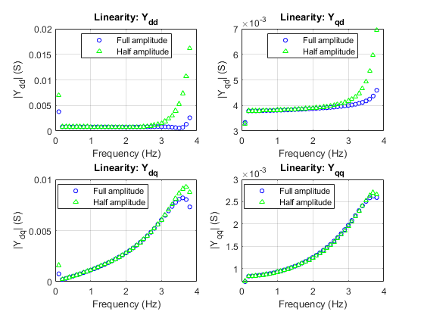
This plot compares the main pulse result with a smaller-amplitude pulse result.
Most admittance elements change very little when the pulse amplitude is reduced. At 0.5 Hz and 1 Hz, all elements pass the linearity check. At 2 Hz, only Ydd slightly exceeds the 10% linearity threshold. At 3 Hz, Ydd changes significantly and fails the linearity check.
Reasoning
Admittance is a small-signal quantity. Therefore, if the pulse amplitude is reduced, the estimated admittance should remain almost the same. If the admittance changes significantly, then the response is either not fully small-signal or that element is sensitive to noise/extraction error.
The large change in Ydd at 3 Hz agrees with the single-tone reference comparison, where Ydd at 3 Hz was also rejected. This gives consistent evidence that Ydd at 3 Hz should not be trusted.
Conclusion
The reduced-amplitude pulse confirms small-signal behaviour for most admittance elements. The main exception is Ydd at higher frequency, especially at 3 Hz. Therefore, the pulse method is reliable for most validated low-frequency elements, but Ydd at 3 Hz should be excluded from final accurate results.

Runtime saving
The pulse method produced 34 accepted frequency bins using only two main PSCAD pulse simulations.
A conventional dq sinusoidal scan needs two simulations per frequency:
1) one d-axis perturbation
2) one q-axis perturbation

Therefore, for 34 frequency bins: 34 × 2 = 68 sinusoidal simulations
The pulse method only needs, one broadband d-axis pulse and one broadband q-axis pulse. So the run-count saving is: 68 / 2 = 34
Run reduction = 34.0× fewer PSCAD runs
The pulse method is efficient because one broadband d-axis pulse and one broadband q-axis pulse can excite multiple frequency components at the same time. In contrast, the conventional sinusoidal scan method normally excites one frequency at a time.
Pulse simulation runtime
Case | Perturbation | Solver step | Plot step | Simulation duration | Stopwatch runtime | Used for
1 | Main d-axis pulse, 0.005 pu | 50 µs | 50 µs | 12 s | 56.19 s | Pulse first column
2 | Main q-axis pulse, 0.5° | 50 µs | 50 µs | 12 s | 55.29 s | Pulse second column
3 | Smaller d-axis pulse, 0.0025 pu | 50 µs | 50 µs | 12 s | 53.14 s | Linearity check
4 | Smaller q-axis pulse, 0.25° | 50 µs | 50 µs | 12 s | 52.30 s | Linearity check

MAIN pulse MATLAB post-processing time = 0.9897 seconds
TOTAL pulse MATLAB validation time excluding plots = 5.1787 seconds
Case | Perturbation | Frequency | Amplitude | Stopwatch runtime
5 | d-axis voltage magnitude | 0.5 Hz | 0.005 pu | 92.5 s
6 | q-axis phase angle | 0.5 Hz | 0.5° | 81.57 s
7 | d-axis voltage magnitude | 1 Hz | 0.005 pu | 80.19 s
8 | q-axis phase angle | 1 Hz | 0.5° | 80.84 s
9 | d-axis voltage magnitude | 2 Hz | 0.005 pu | 81.31 s
10 | q-axis phase angle | 2 Hz | 0.5° | 81.56 s
11 | d-axis voltage magnitude | 3 Hz | 0.005 pu | 79.44 s
12 | q-axis phase angle | 3 Hz | 0.5° | 81.71s

T_pulse = T1+T2+0.9897 = 112.47 s
T_pulse_validation = T1+T2+T3+T4+5.1787 = 222.10 s
T_single-tone = 659.12 s
Speed-up = T_single-tone/ T_pulse = 5.86
Runtime reduction = 82.94%
Validation(linearity) included ; (This includes the smaller-amplitude pulse cases used for the linearity check.)
Speed-up = 2.97
Runtime reduction = 66.3%
Estimated runtime saving for 34 accepted pulse bins
The pulse method accepted 34 frequency bins.
For a conventional dq sinusoidal scan: 34 frequency bins × 2 perturbation directions = 68 PSCAD simulations
T_avg_single-tone = 659.12 / 8 = 82.39 s
T_34bin_single-tone = 68 × 82.39 = 5602.52 s
Estimated 34-bin speed-up = 5602.52 / 112.47 = 49.9×
Estimated runtime reduction: = (5602.52. - 112.47) / 5602.52 × 100 = 98.00%
Conclusion
The pulse method provided a clear measured runtime saving for the four frequencies validated against single-tone scans. The main pulse workflow was 5.87× faster than the eight corresponding sinusoidal simulations, while the complete pulse workflow including half-amplitude linearity validation remained 2.98× faster.
The method also produced 34 numerically qualified broadband bins using only two main PSCAD runs. If the same 34 frequencies were obtained using separate d-axis and q-axis sinusoidal simulations, the projected speed-up would be approximately 49.90×. This projected value should be interpreted as an estimate based on the measured average single-tone runtime.
The projected saving applies only to numerically qualified bins. Final high-confidence use still requires appropriate reference validation, linearity checks and targeted sinusoidal fallback where the pulse method is screening-only or rejected.
Overall result summary
Frequency | Result | Final classification
0.5 Hz | Ydd, Yqd, Yqq accepted; Ydq screening-only | Mostly valid / screening
1.0 Hz | All four elements below 10% error | Fully accepted
2.0 Hz | All four elements below 10% error; Ydd has slight linearity warning | Accepted with caution
3.0 Hz | Yqd, Ydq, Yqq accepted; Ydd rejected and nonlinear | Partially accepted

Criterion | Value used | Why it was used
Input spectral threshold | threshold_dB = -40 dB relative to maximum useful input bin | Rejects frequency bins where the injected pulse has weak spectral energy. If the input voltage is too small, Y = I/V becomes unreliable.
Condition-number threshold | cond_threshold = 10 | Ensures the 2×2 voltage matrix is safe to invert. A smaller value is stricter and avoids noisy MIMO inversion.
Reference acceptance error | ref_tol_pct = 10% | If pulse result is within 10% complex error of the sinusoidal reference, it is treated as accepted.
Screening error | screen_tol_pct = 20% | If error is between 10% and 20%, the point is not fully accepted but can still be used for screening.
Linearity tolerance | lin_tol_pct = 10% | Checks whether reducing pulse amplitude changes the identified admittance. Small-signal admittance should not depend strongly on amplitude.
Minimum cycle count | min_cycles = 5 | At least 5 cycles are used as a practical minimum for low-frequency FFT confidence.
Frequency range evaluated | 0.1–20 Hz | The code evaluates a wider range, but only accepted and validated bins are used.
Response window | 2–12 s | Gives a 10 s FFT window after pulse injection.

The pulse method is a useful low-frequency scan-acceleration method for the average GFMI case, but only for frequency bins that pass input-energy, condition-number, reference-error, cycle-count, and linearity checks. It should be used as a validated low-frequency screening and acceleration method, not as a complete replacement for all sinusoidal scans.
Pulse identification is recommended as a low-frequency screening tool for the Rezonance workflow. A single pair of d-axis and q-axis pulse runs can replace up to 68 dedicated sinusoidal scans for frequencies below 4 Hz, with accepted accuracy for Yqd, Ydq, and Yqq and screening-level accuracy for Ydd. For high-confidence Ydd identification above 2 Hz, targeted sinusoidal scans remain recommended. The method should be classified as useful for screening, not as a direct replacement for all sinusoidal scans in final stability certification.
Amplitude selection
Initial pulse-identification test was performed using A = 0.01 pu for the d-axis voltage pulse and A = 1.0 degree for the q-axis phase pulse, consistent with the perturbation level used in the sinusoidal reference scans.
However, the amplitude-linearity check showed that this pulse level was too large for reliable identification. When the pulse amplitude was halved, three of the four admittance elements changed significantly:
Ydd: 15–52% change
Ydq: up to 91% change
Yqq: 21–37% change
Yqd: around 6% change
This indicates that the 0.01 pu / 1.0 degree pulse was close to, or outside, the linear operating range for this GFMI model and operating point. Since admittance is defined as a small-signal quantity, it should not depend on perturbation amplitude. If the result changes significantly when amplitude is reduced, the extracted value is not reliable.
Therefore, the main pulse amplitude was reduced to A = 0.005 pu for the d-axis pulse and A = 0.5 degree for the q-axis pulse. A further reduced pulse, A = 0.0025 pu / 0.25 degree, was then used for the linearity check.
With the reduced-amplitude pair, the results improved significantly against the 10% linearity threshold. This confirms that the reduced pulse amplitude is much closer to the linear operating range. The remaining issue is mainly limited to Ydd at higher frequencies, especially at 3 Hz, and this point is therefore documented as a limitation rather than accepted as a final result.
This amplitude-selection step is therefore a required part of the pulse-identification workflow for any new model or operating point. The recommended procedure is to first run at the intended amplitude, then repeat at half amplitude, and only accept results where the change is below 10%. For the tested switching GFMI and operating point, the reduced main pulse amplitudes of 0.005 pu and 0.5° produced amplitude-independent results for most validated elements. The main exceptions were Ydd at 2 Hz, which slightly exceeded the 10% linearity tolerance, and Ydd at 3 Hz, which failed strongly. Therefore, amplitude selection must be repeated when the model or operating point changes.
Failure and fallback conditions
A pulse-derived frequency point should be rejected or classified as screening-only when:
- The pulse input spectrum is below the selected energy threshold.
- The dq voltage matrix has a condition number above the selected limit.
- The response window contains fewer than five cycles.
- The result changes by more than 10% when the pulse amplitude is halved.
- The result differs from a trusted single-tone reference by more than the selected tolerance.
- The response has not decayed sufficiently before the end of the record.
- The d-axis and q-axis experiments use inconsistent dq reference frames.
- The operating point or controller mode changes during the pulse.
- A small cross-coupled element produces a large relative error because it is close to the numerical noise floor.
When a point fails these conditions, the recommended fallback is a targeted d-axis and q-axis sinusoidal scan at that frequency.

